**Lab 3**

1. Use min and max filtering technique. Show input and output side by side.

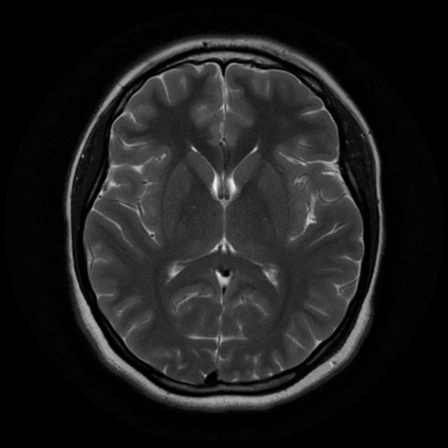

1. Use Gaussian filtering. Show input and output side by side.

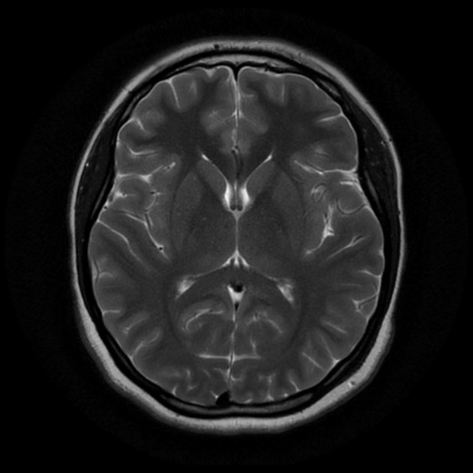

1. Apply the following filters:
2. Box filtering
3. Average filtering
4. Median filtering

Show input and output side by side. Also show the comparison between the 3 techniques. Mention which method works better than others.

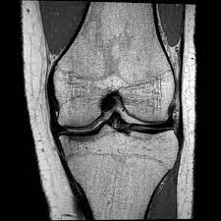

4. Using the following image, solve questions a - f.

1. Read and show the image.
2. Show the matrix form of the image.
3. Show the pixel information by hovering the cursor on the image.
4. Find the value of the pixel (10, 78).
5. Show the size of the image.
6. Show the all the information of the image.

5. Using the following images, solve questions a - i.



RGB Image

Grayscale Image



Indexed Image

* 1. Read and show all three types of images (RGB, Grayscale, and Indexed).
  2. Turn the RGB image to Grayscale image.
  3. Turn the Indexed image to Grayscale image.
  4. Turn the Indexed image to RGB image.
  5. Convert the Grayscale image to a Binary image.
  6. Show the inverted form of that Binary image.
  7. Show the histogram of the Grayscale image.
  8. Invert the RGB image.
  9. Blur the RGB image.